Login to Site administration and login to the desired node you wish to make changes to the COR

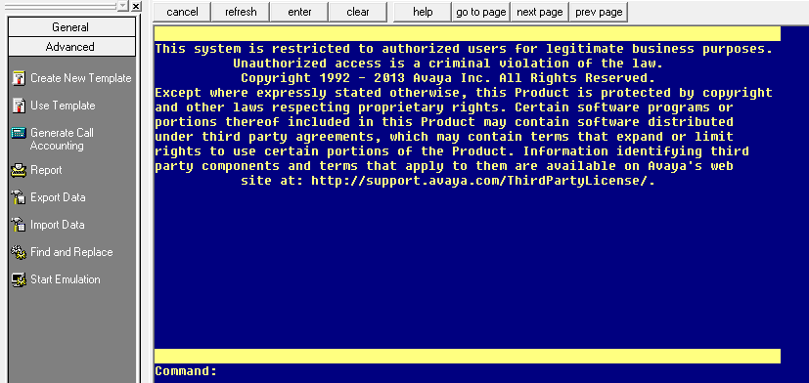

At the left most of the page, click on the advanced tab to select Import data.

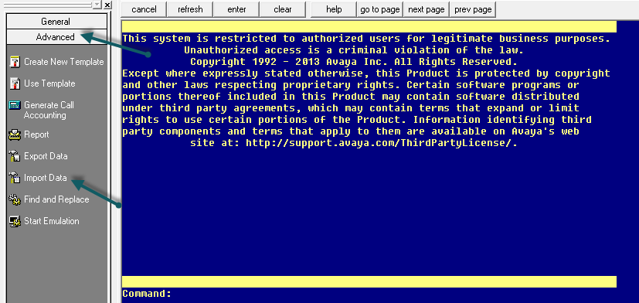

Click on the Import Data on the page to redirect to the Import page.

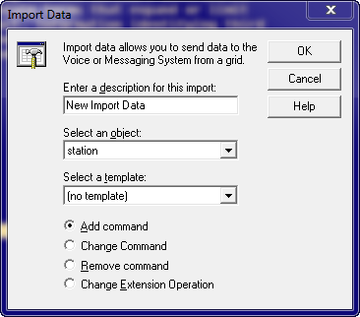

Enter a description you desire to give and leave the object as station( Template is not required but if we have a particular template we can select that in the drop down)

Click on the Change command in the circle beside it and click ok.

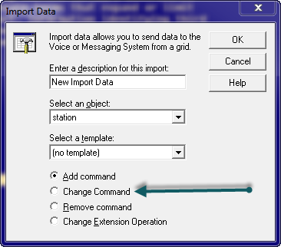

A new spreadsheet with the entire required column, here we add the extension (Station ID) and the COR number you wish to change.

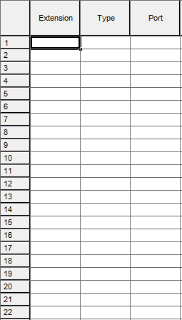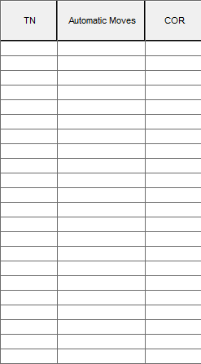

Once this is entered click on the save button  on top of the sheet.

The changes will be done automatically and you can check the changes done in the schedule / history tab below the spreadsheet.